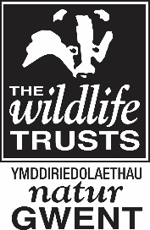

Usk To Wye Grassland Conservation Trainee (Volunteer Post)
Part time 6 month post, Usk to Wye Living Landscape Area

Gwent Wildlife Trust is seeking an individual with a strong desire to develop their skills, knowledge and interest in grassland conservation and management in the spectacular Wye Valley region of Monmouthshire.

A trainee is required to assist with the day to day management of the grassland nature reserves in the Usk to Wye Living Landscape area. They will be part of the Usk to Wye Living Landscape team carrying out conservation land management on nature reserves. There will also be opportunities to work on other nature reserves across Gwent.

A training package is included in the role - leading to relevant qualifications in practical skills for conservation land management together with agreed travel expenses.
Training offered includes ATV use, Tractor Driving and Brushcutter use (NPTC or LANTRA certificates).

This exciting opportunity would suit a recent graduate seeking further experience in conservation grazing and grassland management, or a candidate from an agricultural background looking to develop their conservation skills and knowledge.

A full, clean driving license is essential for this post.

For an informal discussion please contact Tim Green, Senior Farm and Wildlife Development Officer 07799 075734 or 01600 740600
For an application form and job description please visit www.gwentwildlife.org

Closing Date: 15th March 2019
Interview Date: 21st March 2019 at Pentwyn Farm Nature Reserve office.

This project has been supported by the Sustainable Development Fund, Wye Valley Area of Outstanding Natural Beauty (AONB) and The NINEVEH Charitable Trust.

